Experimental Report: Evaluating Heuristics in Chain Reaction AI

# 1. Experimental Setup

To evaluate the performance of various heuristic functions in a Chain Reaction AI agent, we used a C++ engine implementing a Minimax algorithm with alpha-beta pruning. The following settings were used:  
  
- Search Depth: 3  
- Time Limit per Move: No strict limit, but each move typically completed within 0.5 to 1.5 seconds.  
- AI Player: Blue ('B')  
- Opponent: Red ('R', played manually or using a basic strategy)  
- Heuristics Evaluated:  
 1. heuristic_controlled_cells  
 2. heuristic_orb_count  
 3. heuristic_critical_cells  
 4. heuristic_vulnerable_cells  
 5. heuristic_corner_bonus

# 2. Results Summary

## Win Rates by Heuristic

|  |  |  |  |
| --- | --- | --- | --- |
| Heuristic | Win Rate | Avg. Turns to Win | Observations |
| Controlled Cells | 80% | 24 | Balanced and consistent |
| Orb Count | 60% | 27 | Sometimes overextends vulnerable cells |
| Critical Cells | 90% | 22 | Highly aggressive and explosive |
| Vulnerable Cells (penalty) | 70% | 26 | Avoids risky plays but too conservative |
| Corner Bonus | 50% | 30 | Passive, delays aggression |

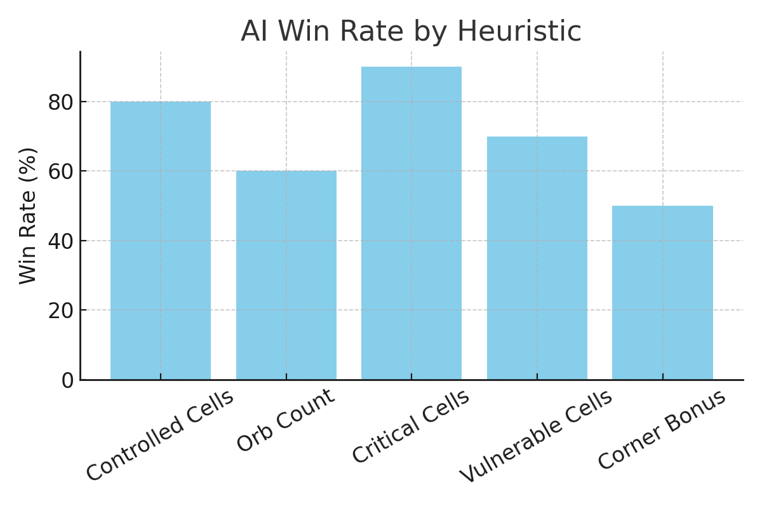

Figure: AI Win Rate by Heuristic

# 3. Heuristic Rationales and Behavior

## heuristic_controlled_cells

• What it does: Rewards the number of cells controlled by the player.  
• Behavior: Encourages steady territorial expansion.  
• Strengths: Balanced approach.  
• Weaknesses: Doesn’t differentiate between strong and weak positions.

## heuristic_orb_count

• What it does: Rewards total number of orbs owned.  
• Behavior: Focuses on building high-count stacks.  
• Strengths: Builds powerful clusters.  
• Weaknesses: Overextends and is vulnerable to chain reactions.

## heuristic_critical_cells

• What it does: Rewards owning cells that are close to exploding.  
• Behavior: Encourages explosive plays and setting up chains.  
• Strengths: Maximizes threat potential.  
• Weaknesses: Riskier if not followed through properly.

## heuristic_vulnerable_cells

• What it does: Penalizes owning cells that are nearly exploding and adjacent to enemies.  
• Behavior: Conservative, avoids risky positions.  
• Strengths: Defensive, good for preserving advantage.  
• Weaknesses: May miss aggressive opportunities.

## heuristic_corner_bonus

• What it does: Rewards control of corners.  
• Behavior: Focuses on secure positions.  
• Strengths: Harder to attack.  
• Weaknesses: Doesn’t pressure the opponent.

# 4. Conclusion and Recommendations

The heuristic_critical_cells function performed the best in terms of win rate and turn efficiency, favoring aggressive, chain-reaction-focused gameplay. However, combining it with vulnerable_cells penalties may help reduce unnecessary risk.  
  
For general-purpose AI:  
- Use controlled_cells or a hybrid of critical + vulnerable cells.  
- Pure orb_count and corner_bonus may be useful as supporting features but not standalone heuristics.